

**University of Nevada Las Vegas**

**Department of Electrical and Computer Engineering**

**EE497 Senior Design**

Spring 2017

**Fiber Optic Sensor for CubeSat**

Final Project Report

**Group Members:**

|  |  |  |  |
| --- | --- | --- | --- |
| Aaron Volpone |  | CpE |  |
| Name (Print) |  | CPE/EE/ME |  |
|  |  |  |  |
| Name (Print) |  | CPE/EE/ME |  |

**Abstract**

The Fiber Optic Sensor for CubeSat is a sensor module designed to be implemented in the future for use in UNLV’s CubeSat project. Compared to conventional angular sensors such as gyroscopes, the fiber optic sensor boasts higher reliability and precision. Fiber optic sensors do not use moving parts. This is a huge leap in reliability regarding to astronautical engineering where repairs are not an option once a satellite is deployed. Ultimately, the fiber optic sensor accomplishes the challenge of angular correction and alignment in space where user controlled steering would be delayed and error-prone.

This fiber optic sensor pulls from larger fly-by-optics applications in planes that take advantage of high data transfer rates all the while remaining discreet and low power. Using a grating mirror and multiple fiber channels, the fiber optic sensor can determine angular moment by detecting the differences in intensity between internal photodiode sensors.

In the scope of UNLV’s CubeSat project, the fiber optic sensor seeks to be modular and lightweight with the possibility of integration into other projects in the near future. Fiber optic sensing is a developing technology with many facets of application for home and industrial use. Fiber optic sensors can be used in tandem or entirely replace conventional CMOS chips thereby saving space and power.

**Introduction & Background**

The UNLV CubeSat project is a multi-year, multi-disciplinary project in which many students tackle different aspects of the satellite’s components. To compliment payload experiments in the future, Dr. Sun has assigned several teams to work on sensors that will be deployed to help payloads conduct their experiments in the future when sent to space.

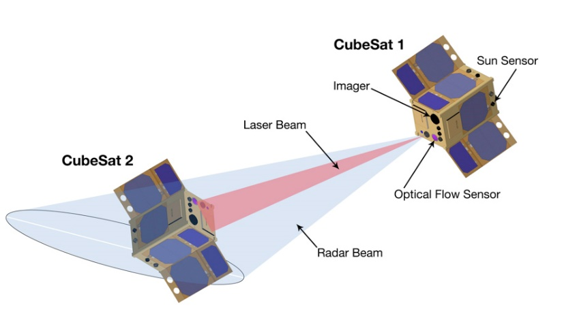Conventional sensors, especially in the field of angular sensing can be cumbersome and unreliable. Mechanical gyroscopes are an established base in many fields of engineering. However, they are prone to bearing wear and suffer from friction which affects start-up time and early measurements. In the field of space engineering, reliability is at the forefront of importance when dealing with extended missions and unfavorable conditions outside of Earth’s atmosphere.

Figure 1 – Example of localized CubeSat detection and alignment. The process of laser beam alignment is done on both satellites.

With the advent of fiber optics, avionics can take advantage of higher precision, lower power instruments. The objective of the fiber optic sensor for CubeSat is to accomplish this exact premise. In space application, it is unknown to other neighboring satellites what orientation and angular velocity they are experiencing relative to each other. As an output laser emits a constant signal source, the angle and intensity of these lasers will be picked up by their companion satellite when deployed in tandem in outer space. With the use of a grating mirror and various photodiodes, the angle of attack for their neighbors can be determined (along with their velocity). An onboard mixed signal processor will receive these voltage values and send reactionary signals to cease rotation and align with along the vector of highest laser intensity. In this project’s regard, this is detection of a 1550nm laser – environmental light provides very little amplification for the photodiode since its spectral response falls in the range of infrared waves (IR).

The fiber optic sensor along with the entirety of the UNLV satellites in space are designed with the intent to be autonomous upon deployment. Due to this, the on-board sensors must be able to react quickly and independent of intervention. A flow of operation will dictate how the satellite will react on its own by checking for specific sensor parameters to determine its orientation. This orientation will include its angle with respect to the Earth and neighboring UNLV CubeSats.

This sensor accomplishes one specific goal. When accompanied with other on-board software and hardware sensors, the CubeSat is capable of carrying out its mission. The fiber optic sensor remains a module that will experience continuous development even after this Senior Design work has ended. It is with this intention that the sensor be easy to grasp conceptually and in implementation.

**Current Market Solutions**

The field of small group satellite engineering is both incredibly expensive and time consuming. UNLV’s CubeSat project will not just be a single year development, but rather a ten year or greater roadmap. As a result, total pricing is currently unknown as payload items and goal changes are not capable of being known at this time.

|  |  |  |  |  |  |  |
| --- | --- | --- | --- | --- | --- | --- |
|  | **Vendor** | **Accessibility** | **Creative Constraints** |  | **Price** | **Comment** |
| **Government**  **CubeSat** | NASA | Government work | ? |  | ? | Requires access to government facilities |
| **Commercial CubeSat** | Clyde Space / CubeSat Shop | Commercial | Yes | $50k to $250k | Needs to be ordered and manufactured by vendor, high cost due to premade parts |
| **UNLV CubeSat** | UNLV | Academic / Commercial | No, self-designed equipment | TBD | Developed parts at UNLV, support from NASA |

Table 1. Comparison of available devices

The field of microprocessors in CubeSat devices remain limited in application. This is because of two factors: limited power requirements and experience in space application currently. As a result, it is either recommended to use processors that have already be tried successfully in the past or attempt to use similar low-power embedded solutions.

|  |  |  |  |  |  |  |
| --- | --- | --- | --- | --- | --- | --- |
|  | **Processing Power** | **Power Drain** | **Price** | **…** | **Strengths** | **Weaknesses** |
| **Home MC / DSP** | Medium to High | Medium | Varies |  | * Fast processing power * Often multi-cored | * High price * High power drain |
| **Ultra-Low Power MSP** | Low to Medium | Minuscule | Varies |  | * High resolution * Low price | * Medium battery life |

Table 2. Strengths and weaknesses of available devices

**Research results**

The field of Computer Engineering does not dive into the theory and application of optical engineering without motivation from the student. Electrical engineering classes that involve this school of study are upper-division, and require some background knowledge of the subject (made possible with physics classes). Regardless, the theory that goes behind the implementation of this fiber optic sensor is concise and easily computable with a mixed signal processor.

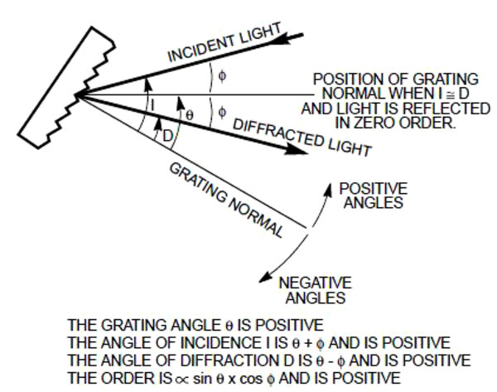In its simplest form, the fiber optic sensor receives an input signal and a processor interprets its signal with the use of photodiodes. With a lens, angular data is carried through with the help of a grating mirror. This grating mirror provides a delta value with respect to its grating normal that allows a sensor to understand what angle an input signal is coming from. In the scope of space application, this means that a companion satellite shooting a laser to its neighbor allows the receiving satellite to receive a mix of distance and angle data. This is due to the nature of light scattering over distance. Thus, the intensity of light plays a role in helping the sensor determine the magnitude of its angular correction to prevent overcorrection.

Figure 2 - Shown is a grating sensor with its impact light differential and incident point. These angles with respect to the grating normal help determine what angle a signal is coming from.

The rest of signal interpretation from the photodiode to the mixed signal processor is simple in implementation. Since photodiodes output extremely small voltages, an operational amplifier will be needed to make the signal significant enough to be used by the central processor. The rest is done in software with the use of an ADC and various equations to output voltages.

**Specification of the project**

**Functionality & conceptual design:**

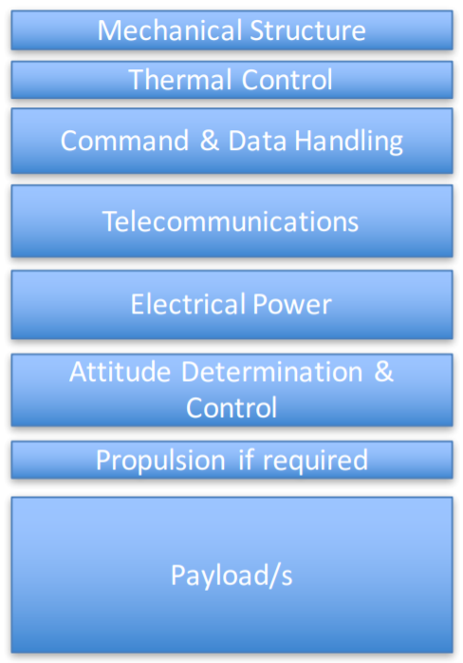In the grand scheme of CubeSat operation, the fiber optic sensor serves a very specific purpose. It is modular and capable of being used in tandem with other sensors.

Displayed in Figure 3 are the various fields of operation that a CubeSat needs to function. The fiber optic sensor falls under the category of attitude determination and control. This module serves to control the satellite that the sensor is installed in - this becomes important when considering the intent to launch UNLV CubeSats in multiples of 2 so that they may collect data and communicate with each other.

The case of attitude control is made possible by the cross-communication between these paired satellites. Each satellite is equipped with a laser that emits a steady beam into open space with the objective to be detected by its neighboring satellite. Before precise attitude corrections, each satellite performs basic maneuvers to align itself with the Earth through use of a gravity sensor. Once established, a sort of feedback loop occurs in each satellite to begin orientation toward each other.

Figure 3 - The various facets of the CubeSat are listed in terms of purpose. The fiber optic sensor falls under the category of attitude determination and control.

This involves the following:

* 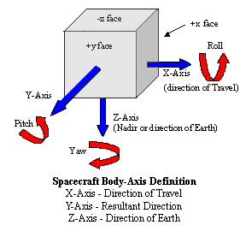Both CubeSats searching for emission of a 1550nm signal on all sides of the cube. If none are found, CubeSat 1 will start rotating on one axis. This will alternate between X, Y, and Z until any remnant of a signal is detected.

Figure 4 - The various axis that the CubeSat must account for when correcting angular differences.

* Upon detection, intensity values are interpreted in both satellites and narrowing of angular difference between the two satellites begin.
  + CubeSat 1 will correct and rotate toward point of higher intensity.
  + CubeSat 2 will correct and rotate toward point of higher intensity.
* Feedback from this constant cycle helps both satellites remain independent from each other while allowing them to meet halfway in alignment.
* Once a certain threshold is met, the satellite with stop angular correction and attempt a communication link.

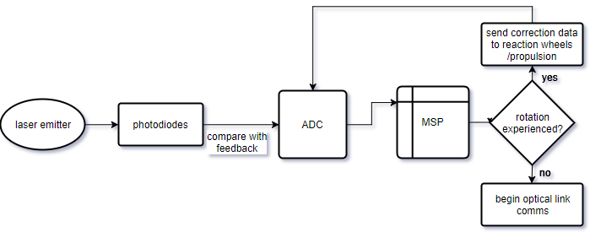

Figure 5 - An example of the flow of data for input laser to the MSP.

**Architecture:**

MSP (mixed signal processor)

* MSP432P4 microprocessor
  + Ultra-low power
    - Starting at 80 uA/MHz active mode
    - Down to 660 nA LPM3 (With RTC)
    - Wake-Up From Standby Mode in <10 uS
    - Enhanced Low-power peripherals
  + ADC
    - 24-ch, 1MSPS 16-bit precision (13.2 ENOB) SAR ADC
    - Up to 16 ENOB with software oversampling
    - 450 uA at full speed
    - Differential mode support

The central processor for the UNLV CubeSat was chosen with the intent of not only handling sensor data for the fiber optic sensor but other modules as well. The capabilities of the processor needed to be flexible, low-power, but still fast enough to process sums of data in ultra-low power modes.

For this project, the MSP will be handling six ADC channels that will be the input voltages from the photodiodes assigned to receive light from the laser. These ADC values are calibrated so that non-zero voltages will have an angular max and min value that the satellite will be trained to adjust to.

Laser emitter

* QDFBLD-1550-2EM
  + 2mW @ 1550nm wavelength
  + Single mode fiber pigtail

The laser diode is a simple component to the fiber optic sensor. It is designed to be the variable component of the project which affects photodiode readouts. This is accomplished by adjusting the angle of incident when coupled with its lens and grating mirror. As described early, the incident light can vary depending on angle which will vary the voltages of specific mounted photodiode on the receiving end of the grating mirror. For the project, the laser is statically mounted, and the fiber coupled end can be adjusted to vary the angle of incident.

Photodiodes (6x)

* QPDF-200
  + InGaAs PIN photodiode
  + Specialized responsivity at 1550nm wavelength
  + 200um diameter active area
  + Single mode pigtail

The photodiodes in the fiber optic sensor package serve the strict purpose of converting light energy into electrical energy. These diodes operate best at a very specific responsivity (1550nm). For this project, the photodiodes are mounted facing toward a grating mirror. This allows them to receive the angled incident light that comes from the laser emitter.

Since the refracted light will vary in a 2-dimensional plane, the photodiodes will be mounted such that the six of them will create a ring facing into the grating mirror. Depending on which photodiodes are illuminated (and with varying intensities) the MSP will determine which angle the satellite would be rotating at.

Grating mirror

* Model number TBD
  + Dimensions currently unknown
  + Refracts light if used as a grating mirror
  + Refracts light on the opposite side of lens if transmission

The grating mirror’s specifications are still to be determined as of the data that this report has been written. Its general concept is shown above in *Figure 2* where it generates a change in incident angle from an input. If its grating properties are known, it is possible to determine the angle of diffraction from incident and thereby create a proportion between input and output.

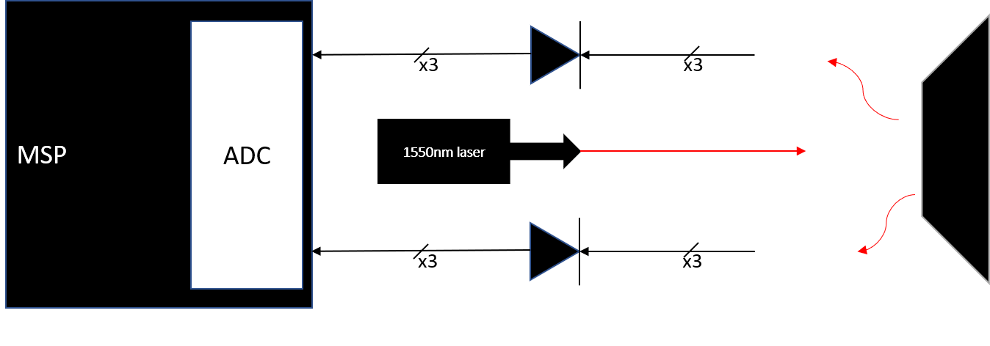Calibrating a proportion for this input (laser emitter) and output to the photodiodes is the goal for this project. This calibration will tie all components together seamlessly so that the MSP can treat the fiber optic sensor module as just another input for the ADC’s.

Figure 6 - The physical layout of the fiber optic sensor. The laser emitter is the initial input but the MSP will receive the voltage values from the photodiode.

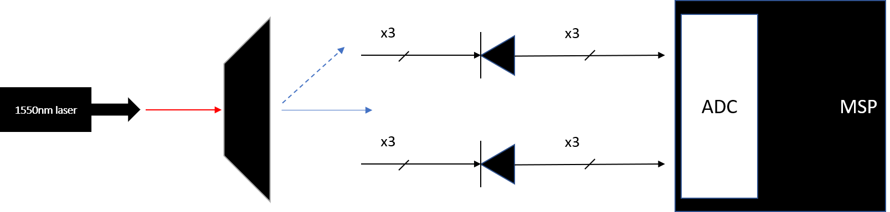Another implementation method for the fiber optic sensor is to use a transmission grating item instead of a mirror. With this method, the entirety of the sensor is more linear and takes up less space when compared to having to work around the laser package. The idea of the transmission grating setup is shown below:

Figure 7 - The transmission grating method operates like how Figure 6 is setup. The only difference is that refraction occurs on the other side of the grating lens, which can help the sensor module benefit from linearity and ease of complexity.

As shown, the angle of incidence will dictate the refraction of the light as with the implementation in Figure 6. However, with the transmission grating method, the refraction will occur on the other end of the grating lens. Depending on the type of transmission grating lens, the incoming light source may be scattered into various orders of light. For the purpose of this project, we are only concerned with the 0th order light – the original wave traveling through the grating item.

The design of this physical layout will be expanded upon more in the design description. For the early development process of this sensor, the input laser will not be from another satellite. Rather, the laser emitter will be controlled locally and calibrated in the lab until sufficient data can be used to show how calibration works. Once this is accomplished, minimization can occur, which is likely the case in future revisions of this project down the road.

**Design**

MSP (mixed signal processor)

* MSP432P4 microprocessor

The MSP is the central piece of equipment for the project. It is responsible for both powering its peripherals and computing data fed from the photodiode sensors. Since the MSP and peripherals were meant to be used in the environment of space, low power usage was a primary focus. The MSP432 is capable of operation in voltages as low at 1.62V. The operating capability of the entire sensor package is still to be determined since full lab testing has not taken place yet.

The pin I/O for this project is limited but each have important purposes for relaying information to the user for data collection and debugging.

* UART

UART communication will be used to relay information back to the user for debugging. This is especially useful for calibration. The 6 input channels for the photodiodes will be used as data to be readout to the user. The frequency of updates will be determined once lab testing has begun.

* ADC

Six ADC channels will be used in total for the varying photodiodes used to interpret angular data. Calibration is necessary to determine what each photodiode will represent in terms of the direction of movement. A min/max voltage will also be determined in lab use. The expected range will be somewhere between 0V to 3.3V or 5V depending on current draw.

The various features of the MSP are shown in the following pages.

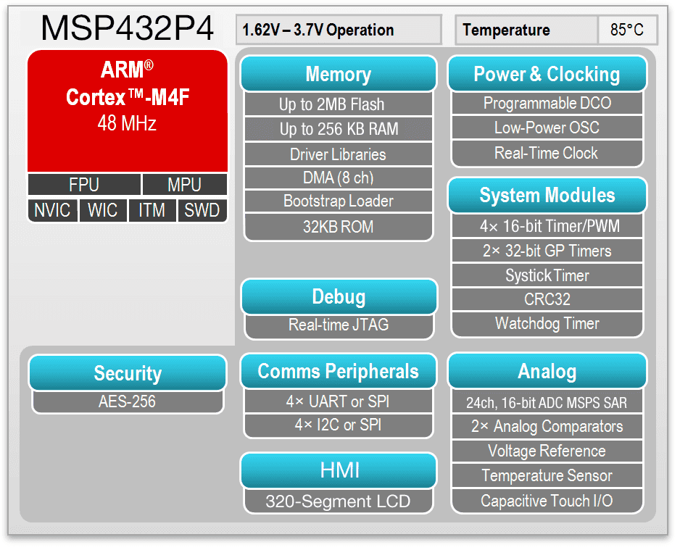

Figure 8 - Some highlighted features present in the MSP432P4 chip.

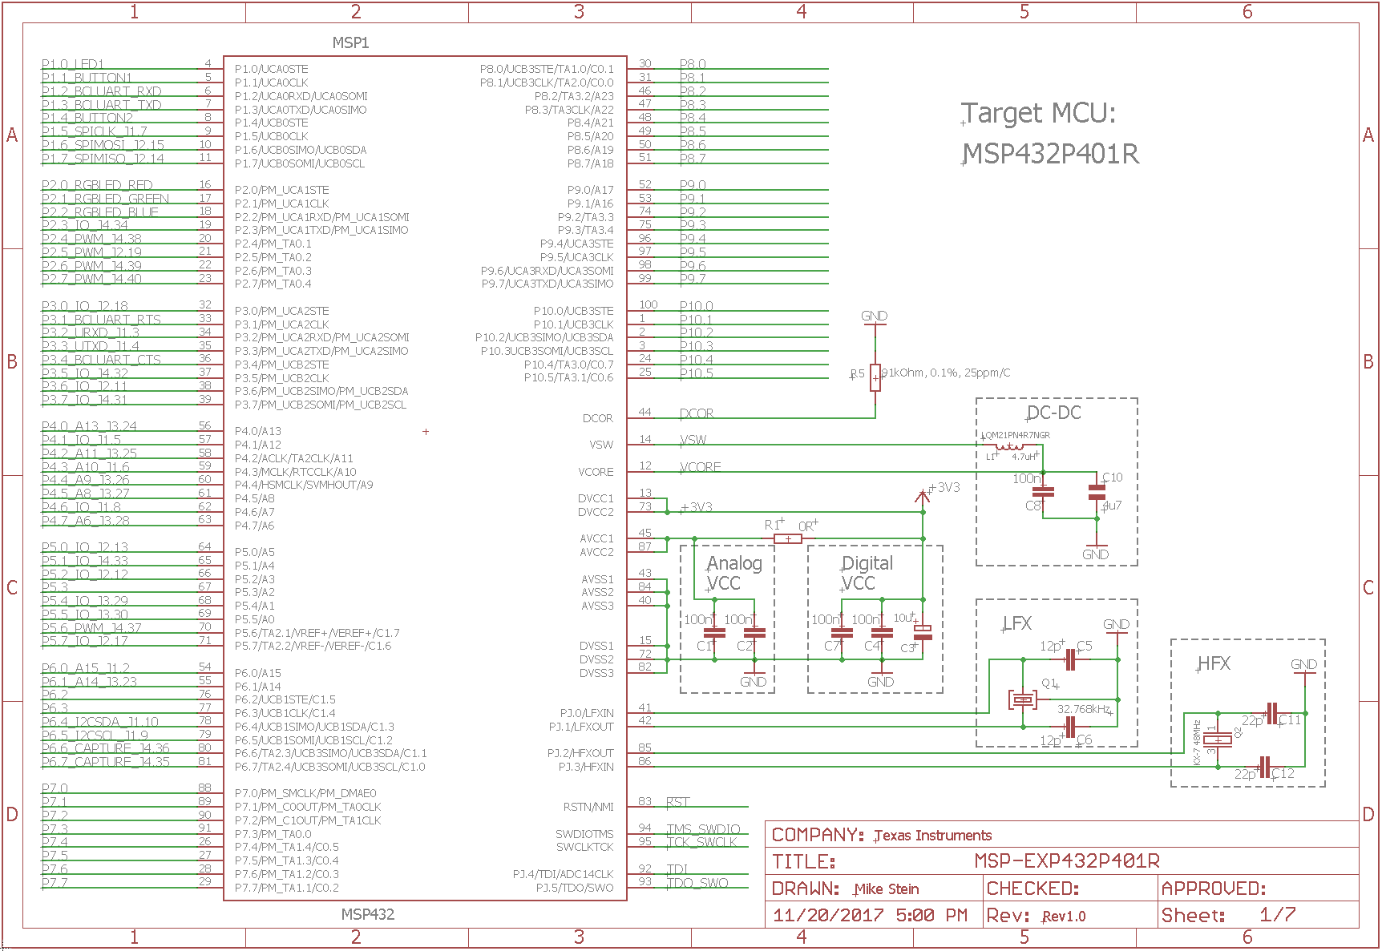

Figure 9 - The shematic of the MSP432, the ADC channels are the main focus of this project.

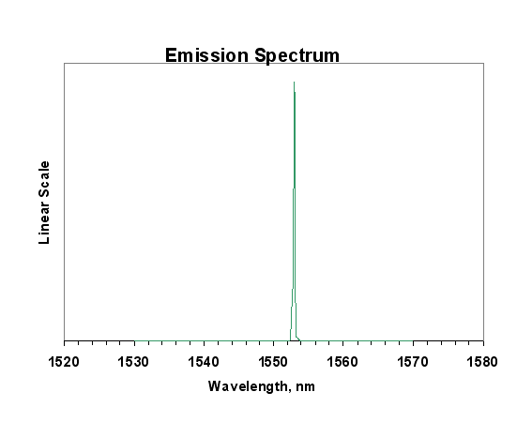Laser emitter

* QDFBLD-1550-2EM

The laser diode will operate strictly in continuous-wave mode. That is, instead operating with a pulsed signal, the laser will stay in a perpetual “on” state. The forward operating voltage of this device is only 1.2V, so compatibility with the rest of the sensor’s items will stay within a reasonable low-wattage expectation. For use in the optics lab, the butterfly package that the laser is encompassed in will provide adequate accessibility to features such as integrated cooling and modes of operation.

Figure 10 - The emission spectrum of the laser. It is specifically designed to output an IR, 1550nm wave.

The laser outputs a solid 1550nm wavelength. This is beneficial in the application of fiber optic technology because it does not attenuate strongly – meaning that signal loss is negligible.

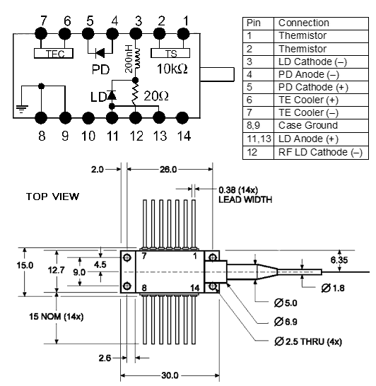

Figure 11 - The pin layout for the 2mW laser. The addition of the TEC cooling system is still not regarded as necessary at this point in the project.

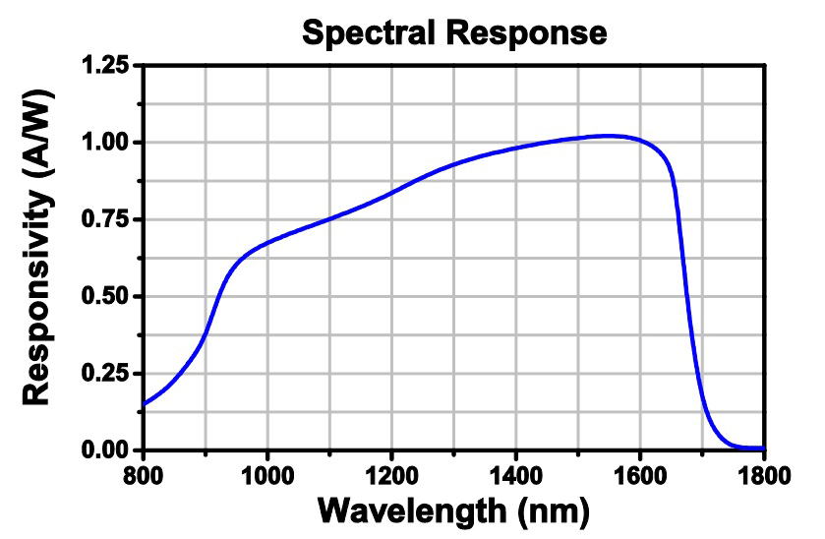Photodiodes (6x)

Figure 12 - The spectral response of the photodiodes. These specific diodes are tailored to respond the best to 1550nm wavelengths.

* QPDF-200

The photodiodes are responsible for converting photons into an electrical signal. These will be reversed biased, so the positive and negative terminals will be oriented in reverse as shown in Figures 6 and 7. Currently, it is unknown what voltage will be used across all photodiodes. This is important to consider because the responsivity of the diodes will change depending on what voltage they are reverse biased as.

Depending on the output voltage, the photodiodes may need to be voltage amplified. This can be done with an op amp circuit. A figure of the dimensions and pin layout for the photodiode can be seen below.

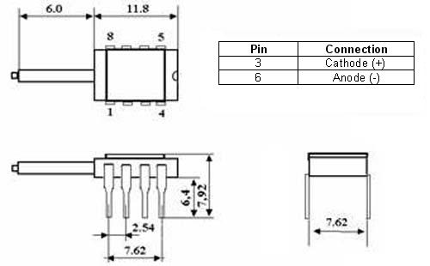

Figure 13 - The dimensions of the photodiode that is compatible with DIL socket applications.

Grating mirror

* Model number TBD
  + Dimensions currently unknown
  + Refracts light if used as a grating mirror
  + Refracts light on the opposite side of lens if transmission

The grating mirror’s model number is still to be determined. Thus, the dimensions and other specifications for the product cannot be supplied until then. However, it is expected the grating item used be specialized to refract wavelengths in the NIR (near infrared) range.

Figure 14 - The difference between transmission grating and reflection grating.

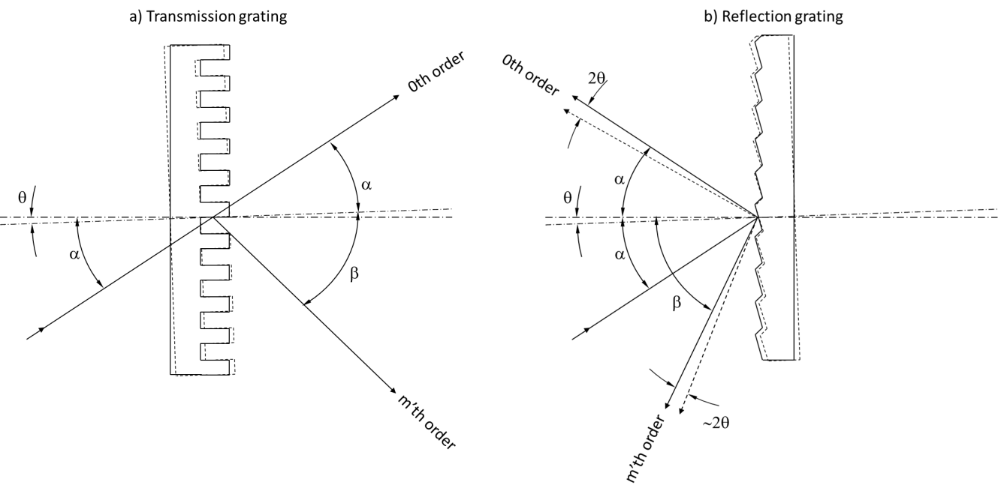A brief overview of Figure 8 shows how the incident wave behaves after impact of the grating. For the transmission grating, it can be seen how the 0th order wave is preserved even after passing. The 1st order and up is not a concern so far for the project unless these is a need for purpose of precision or using the scattered waves. Understanding how alpha deviates from the 0th order wave after transmission will be necessary for calibrating the MSP once photodiodes are wired to the ADC.

Following the Figure 15, the relationship between incident and normal are made apparent with the beta equations.

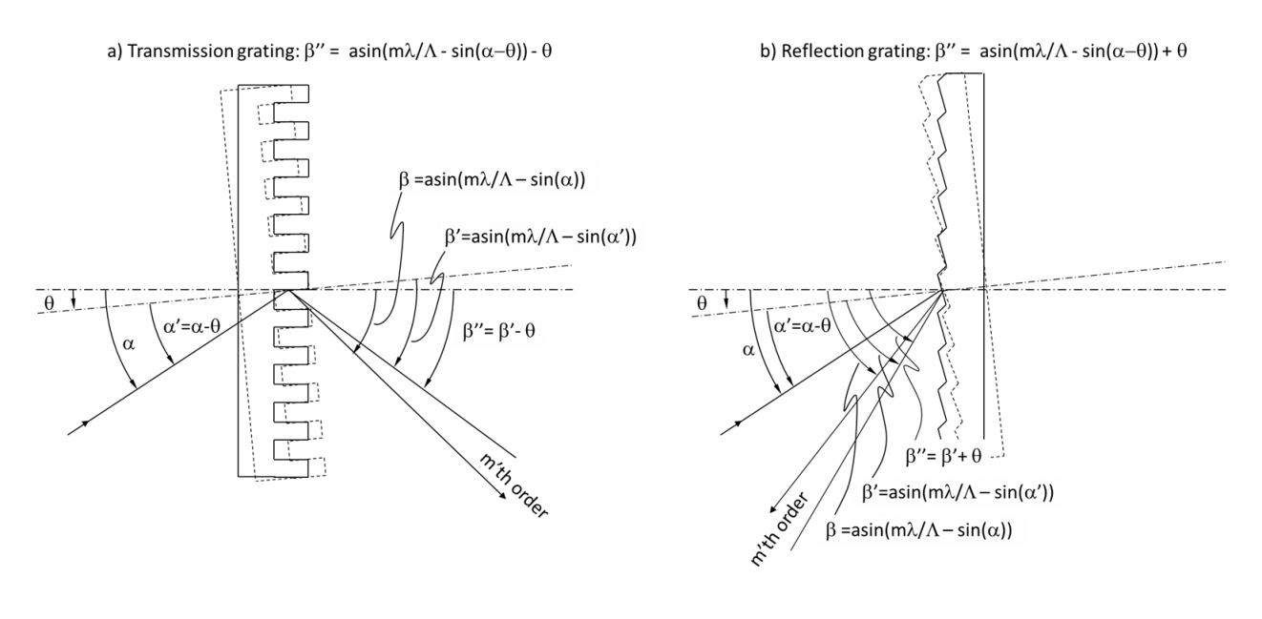

Figure 15 - Calculating the incident angle along with m'th order angles afterward.

**Simulation**

No simulation documentation has been created yet. The photodiode configuration is still to be determined, as the relationship between photon intensity and voltage is being calibrated alongside the MSP ADC.

**Testing**

Testing is to occur over the span of finals week and into winter break.

Initial design will only include one photodiode for the sake of simplicity and assurance of that the proof of concept works. Once biasing is complete, calibration of photo intensity to voltage is necessary.

**User's manual**

The configuration of the fiber optic sensor is split into two parts: hardware and software.

The hardware aspect of the sensor is relatively simple since there are so few parts as of this time in the project. First and foremost, the laser should be the first to set up and power since it will be the foundation of the project. Powering of the module can work in two ways. Since the expectation is to use the sensor in its totality in space, it’s entirely possible to power the MSP and other peripherals with a local 3.3V battery arrangement. Of course, it may also be powered by a dedicated voltage supply as well. A butterfly socket is necessary to seat the laser, powering it is as simple as assigning the wires for VCC and GND.

The grating must be handled with care, so nitride gloves are important as to not contaminate the grating surfaces with oil and dirt. Additionally, the grating must only be held by the corners and delicately placed into a mount. It will face toward the end of the laser’s fiber coupled end.

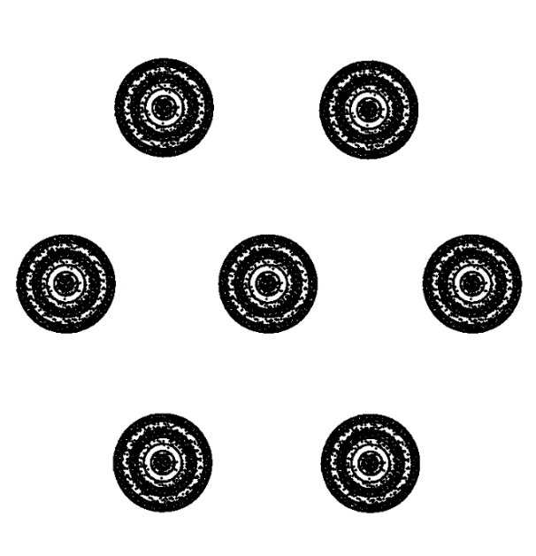

If using a transmission grating, the photodiode’s fiber coupled end will need to face in an array formation into the lens. If using a reflection grating, these photodiodes will face into the mirror but along the same side as the laser. An example of the array planned to be used in the sensor is shown in Figure 15.

As of now, the photodiodes are reverse biased on a breadboard and the output voltages fed into the ADC channels of the MSP. These must be configured to receive input through an IDE. Additionally, the ADC channels must be referenced such that a min/max voltage value can be understood. In the case of this project, current voltages are expected to range from 0V to 3.3V or less.

Software consideration is needed for this project. The IDE of choice is Texas Instrument’s development software known as, Code Composer Studio. It is necessary to download to proper drivers for the MSP432 and configure it to receive inputs from ADC pin 0 to 5. To further debug the voltages received from the photodiodes, UART may be needed. These allow the output data to be sent to a serial reader like a command line so that the ADC channels can be displayed to the user. This is optional as UART is not a necessary component for satellite operation once the sensor is complete.

Figure 16 - The honeycomb array of photodiodes can be better visualized here. The center dot can be imagined as the laser's output which is pointed into the grating.

**Roles & skills in the project**

Provide all the roles with skills, required in the project. Relate each role with the objects present in *Architecture* section. Each object from *Architecture* section must be listed in this table.

|  |  |
| --- | --- |
| **Required skills** | |
| **Microcontroller programmer** | * C, C++ knowledge * Embedded systems understanding * Knowledge of Texas Instruments IDE for board development |
| **Analog to Digital Signal Processing** | * Knowledge of image processing algorithms * Understanding of fiber optics engineering |

Table 3. Roles & skills

List all the roles mentioned in Table 3 and assign names of team member to each role:

|  |  |
| --- | --- |
|  | **Assignment** |
| **Microcontroller programmer** | Aaron Volpone |
| **Optical engineering** | Aaron Volpone |

Table 4. Roles assignment

**Parts list**

Include datasheets as attachments if you have them (Att. id is the attachment id – for example: “1” means “Attachment 1”.

|  |  |  |  |  |  |
| --- | --- | --- | --- | --- | --- |
| **Part type** | **Vendor** | **Model** | **Parameters** | **Picture** | **Att. id.** |
| Microcontroller | Texas Instruments | MSP432P401R | Mixed signal processor |  | See reference link[1] |
| Laser emitter | QPhotonics | QDFBLD-1550-2EM | Light source |  | See reference link[2] |
| Photodiodes (x6) | QPhotonics | QPDF-200 | Light input, voltage output |  | See reference link[3] |
| Multichannel fiber cable | Supplied by Dr. Sun | TBD |  |  |  |
| Grating, either reflective or transmissive | TBD | TBD |  |  |  |

Table 5. List of required parts

**Current form of a project**

The project currently consists of software implementation of the MSP through the evaluation board. Additionally, optics components are in possession but need to be set up in the optics lab. This includes finding the butterfly package module and various mounts for the optical components.

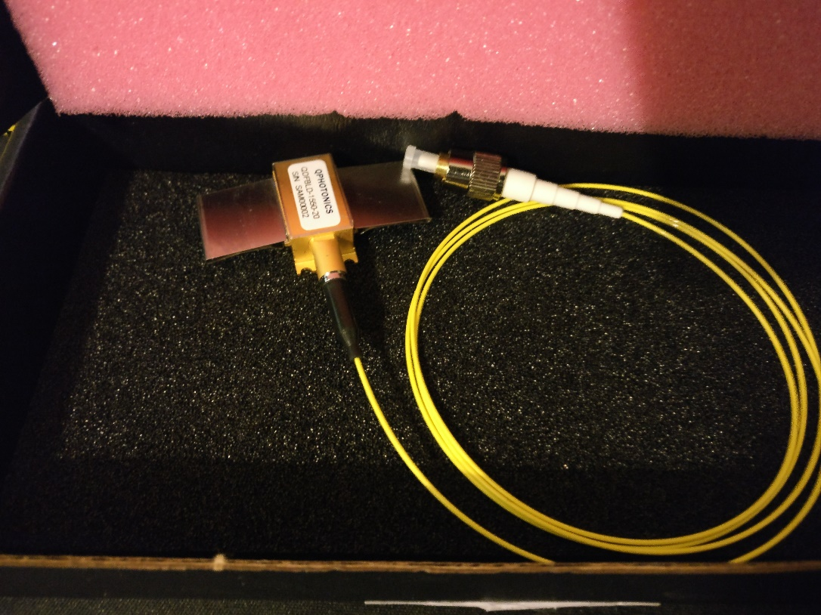

Figure 17 - The laser module for the sensor.

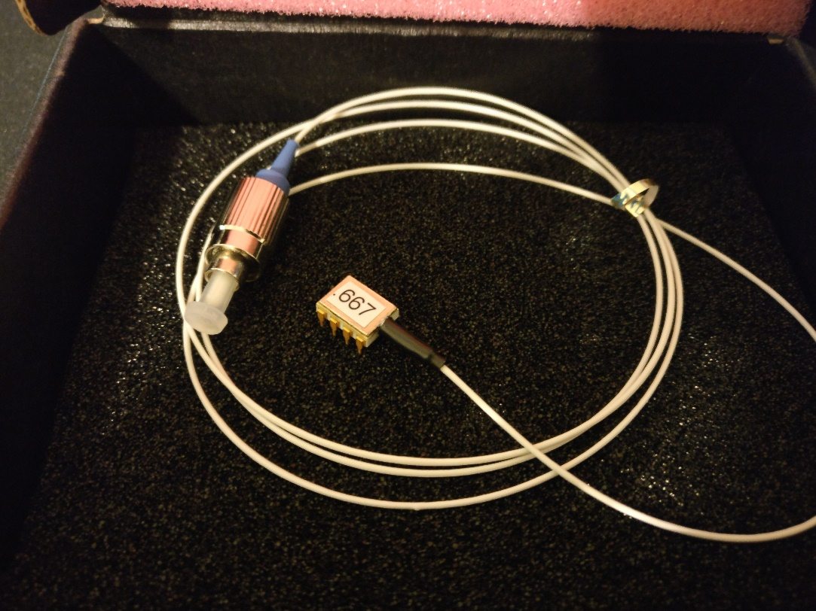

Figure 18 - The photodiode, there will be 5 more once testing occurs with the first one.

**Tests**

No tests have been conducted thus far. The laser and photodiode packages arrived late in the semester, so they still need to be installed in the optics lab.

**Project timeline**

The project timeline for next semester will flex with the flow of progress for calibration of the grating mirror. Once a good methodology is developed for understanding the extent of delta values generated by minimum and maximum detected angular motion.

**Week 1:**

* Evaluation board and optical components are operating.
* Data can be analyzed from grating mirror.
* Start development process of PCB for MSP and photodiodes

**Week 2:**

* Software calibration with single photodiode

**Week 3-5:**

* Complete calibration and begin optimization with 6 photodiode array
* Finalize PCB development, likely print first prototype

**Week 6:**

* Data collection and visualization for photodiode output

**Week 7+:**

* Data collection and visualization for photodiode output
* PCB implementation
* Revise software process (minimization, check power constraints)

**Problems to solve**

**Current problems**

* **Testing platform**: Another Senior Design team is working on the testing platform for which two CubeSats will be mounted for testing. Without this device, the true capability of the sensors can’t be tested in 6-dimensions of freedom.
* **Power usage**: It is currently uncertain how much power draw will be used when the MSP is in full operation with calculations.

**Undecided issues**

* **Alternative testing**:Access to the SEB optics lab is limited in both space and flexibility in angular testing. The distances between the laser and photodiodes will be limited and as a result, calibration will be limited to this kind of environment.

**Final remarks**

Being a solo project, work is being done to determine the end expectation of this modular-based project.

**References**

Include all the documents that you cited / referred to in the whole document

Visible Transmission Gratings – Thorlabs, Inc.

Grating tutorial – Thorlabs, Inc.

Diffraction Grating Equation with Example Problems – Emmett J. Ientilucci, Ph.D

<http://www.ino.it/home/lucamerca/Esercizi%20Reticolo.pdf>

-

[1] MSP432 documentation and description:

<http://www.ti.com/tool/MSP-EXP432P401R>

[2] Laser diode product page (QDFBLD-1550-2EM)

<http://www.qphotonics.com/Wavelength-stabilized-single-mode-fiber-coupled-DFB-laser-diode-2mW-1550nm-QDFBLD-1550-2EM.html>

[3] Photodiode product page (QPDF-200)

<http://www.qphotonics.com/Wavelength-stabilized-single-mode-fiber-coupled-DFB-laser-diode-2mW-1550nm-QDFBLD-1550-2EM.html>